Class CS_UC211 Number 202115030121 Name Hao Yang

Machine number Experiment date 2022/11/13 Report date 2022/11/23

**Experiment topic:**

**1.Overview**

In addition to completing the basic experimental tasks, we also completed the functions of sorting polynomials in ascending order of exponential power and reversing polynomials.

The C++ library functions are used to complete the compilation of test data. Run the basic functions many times to get the data of monitoring time.

Further mastered the contents of the linked list.

**2.Experimental scheme**

2.1 Design scheme

Linked list storage. Encapsulate the polynomial class. After completing the basic function, create a new file, write polynomial test samples and data reading functions. Then create a new file to write polynomial reading and basic operation time test.

The running process is: read the polynomial sample, cycle through the two polynomials in turn, perform basic operations and write them to the file, and then run for more than 1000 times, record the running time and write it to the file.

2.2 Function call relation

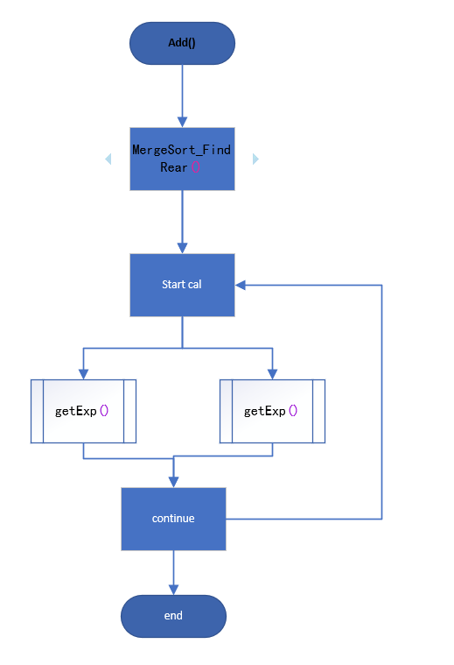

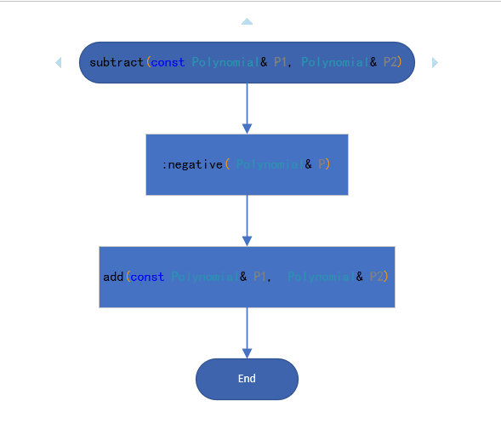

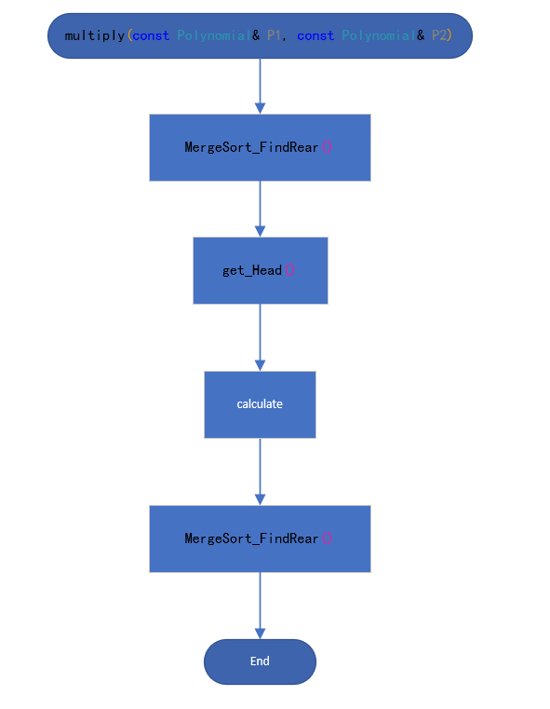

2.3 Key algorithm implementation

* Po* Polynomial::mergeSort(Po* nowLink)

Merge and sort the linked list.



* void Polynomial::add(const Polynomial& P1, Polynomial& P2)



* void Polynomial::multiply(const Polynomial& P1, const Polynomial& P2)

Add two polynomials.



**3.Experiment process**

3.1 Test process

The test data is too large. Files in the same folder.

3.2 Debugging analysis

* Defined more than once.

Add #pragma once a file.h

* After addition and subtraction, the two polynomials are changed.

Deep copies of two polynomial chains are made into two new polynomial chains. Operate on these two new polynomial chains.

* The number of terms of each polynomial is less than one.

A logic error occurred while stacking the counters.

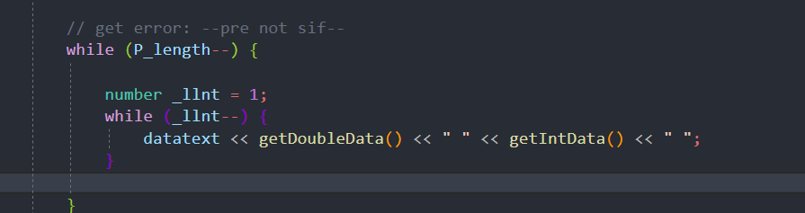

**4. Evaluation analysis**

4.1 Analysis of experimental results

The basic tasks of the experiment are completed. The first 20 polynomials are checked to verify the correctness of the experiment.

At the same time, based on Python data analysis, the relationship between running polynomial item number and running time is obtained.

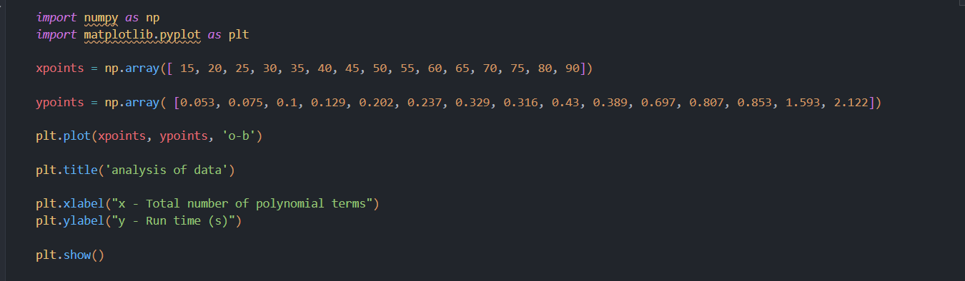

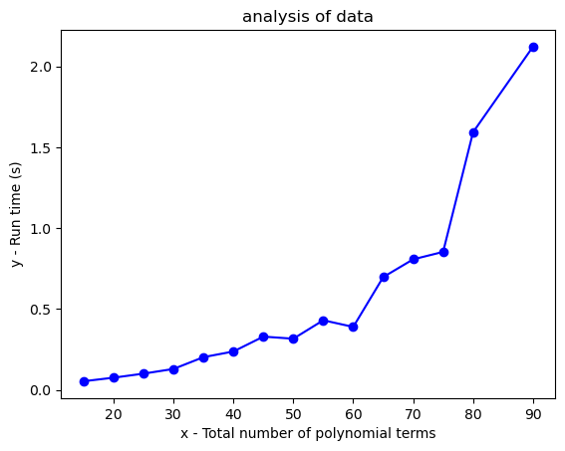

4.2 Algorithm performance evaluation

It is unnecessary to sort polynomials in addition, subtraction and multiplication. This part can be sorted uniformly after inputting a complete polynomial, without having to operate in the process of basic operation.

It is also unnecessary to make deep copies of polynomials. Because polynomials are chained storage, polynomials with the same head node will change after changing the order.

**5.Summary and experience**

* Have a further understanding of C++multi file programming.
* Remember to back up when writing code.
* For linked list operations, remember to point to the next node.
* Code naming is standardized and uniform.